Prospective New Member  CPM  St. Louis, MO | 
Last Updated: Mar 8, 2025 by Frank Moneymaker

Deal Overview
tl;dr
- Thesis: Acquire a scaled, growing management company in the St. Louis metro area with high retention rates and a sizable maintenance business.
- Key stats (FY 2024):
  - $8.7M of revenue, $4M of mgmt. Fees, and $2.3M of LTM EBITDA (27% margin)
    - $7.9M of LTM revenue and $1.5M of EBITDA (20% margins) when excluding earnings credit income
  - 244 CAs, 37.9K doors, 63 Employees
  - 4-yr retention: 97% CA
  - CAM Cut: 41%
  - Revenue Mix: 46% Mgmt fee, 34% maintenance income, 9% earnings credits, 6% transfer fees, 5% other revenue
- Opportunities / Growth:
  - Expand the company’s presence in Illinois and Columbia
  - Further develop sales and marketing function to accelerate growth
- Considerations / Risks:
  - Both owners would like to walk away from the business over the next couple of years, meaning we would need to hire and train a new President, particularly to lead business development, and likely a Controller
  - The maintenance division accounts for over a third of revenue – we would need to understand cyclicality and any downside potential
  - CPM has 30% of its CAs in Illinois and another 21% in Columbia – we’d need to better understand the quality of their operations in those two secondary markets
  - There are a couple managers considering retirement – we’d need to reshuffle and rehire for these positions
- Software and Banking:
  - Client Accounting: Vantaca & Spectrum
  - Corporate Accounting: Vantaca
  - Transfer & Resales: CondoCerts
  - Payroll: Innova
  - Client Banking: First Citizens
- Ownership:
  - Bob (CEO): 47.5%
  - Jane (President - runs corporate accounting): 47.5%
  - Bobbie (CFO - runs client accounting): 5.0%
- Transition Plan:
  - Roles
    - Bob would like to transition out in a year
    - Jane would like to work PT or FT for 1-2 years in an advisory role
- Other relevant info:
  - CPM Data Room
  - CPM Info Sheet
  - CPM Diligence Workbook
  - CPM Info Call
- Recommendation:
  - Propose an LOI for an MC opportunity structured as:
    - $20M EV @ Closing (~10x PF EBITDA, 8.6x TTM EBITDA)
      - $17M Cash at Closing
      - $3M Seller Note
      - 2026 earnout paying 10x any incremental EBITDA above $2.4M (10% hurdle)

Transaction overview
CPM is based in St. Louis, Missouri, with offices in Columbia and Illinois. The company services 244 CAs and 38K units, with 63 employees. This organization has a sizable maintenance business, representing over a third of total revenue. CPM is owned primarily by Bob and Jane, who each control 47.5% of the company. Their CFO, Bobbie, owns the remaining 5%, and manages client accounting. Bob and Jane would like to retire, and expressed interest in selling the company so they could transition out over next year or so. To our knowledge, they aren’t talking with anyone else.

Transaction Details

Preliminary Underwriting EBITDA and Valuation (Member Company)

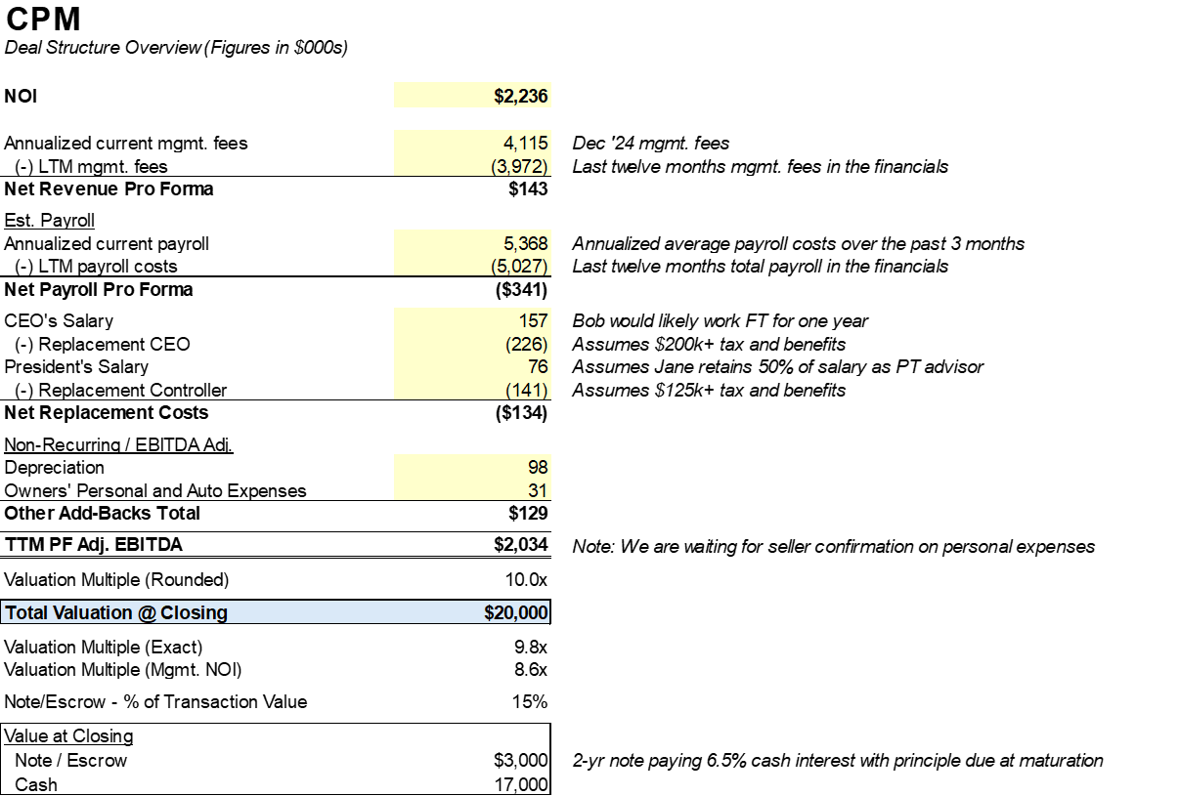

PF EBITDA: The PF EBITDA adjustment includes a significant increase in personnel costs, driven both by the replacement costs of new leadership as well as annualized payroll costs for new employees hired over the past year.

Valuation: ~10x PF EBITDA at closing ($20M EV @ Close) with 15% in a seller note.

Seller Note: 2-year term with a 6.5% cash interest rate, interest paid quarterly with principal due at maturation.

Earnout: 2026 earnout paying 10x any incremental EBITDA above $2.7M which is 10% growth p.a. from the current PF EBITDA. To discuss inclusion.

Employment Agreement: We would sign a one year employment agreement with Bob and Jane with the opportunity of continuing to work part time after if she’d like. We’d also sign a two year employment agreement with Bobbie.

Summary Income Statement
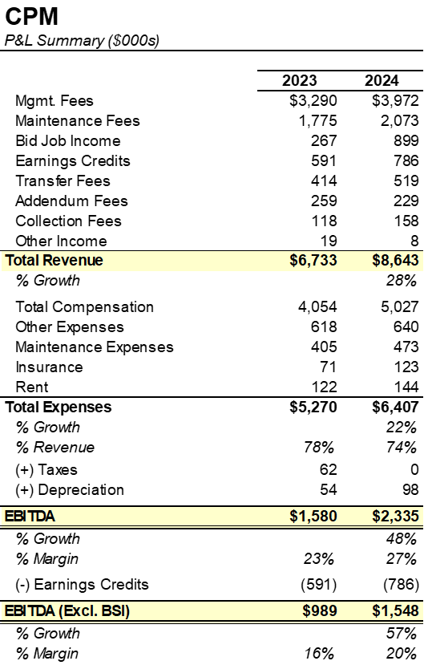

Commentary
The company derives significant income from maintenance revenue (50% of management fees, similar to W360). CPM is a high margin organization (20% excluding earnings credits) with over a third of overall revenue generated from the company’s maintenance income.

Revenue Breakdown
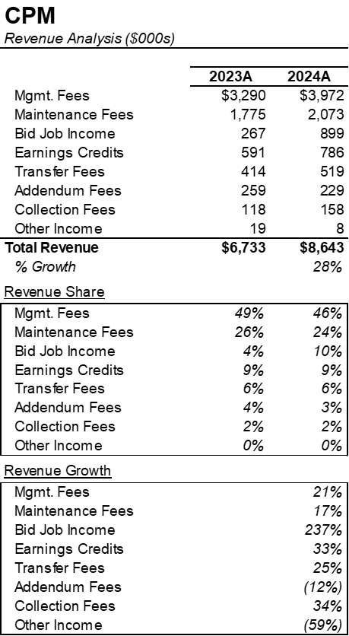

Commentary:
Bid job income tripled from ‘23 to ‘24, driven by [ ]. The increase in earnings credit income was due to the timing of CPM’s earnings credit agreement with First Citizens beginning in May 2023.

Customer Analysis
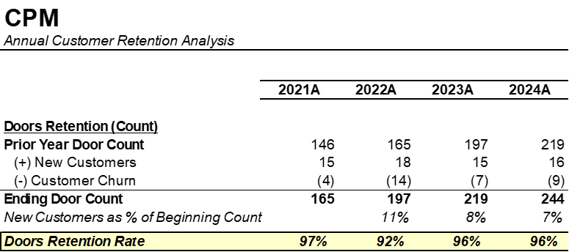

Commentary:
CPM’s customer retention is above average, and has been stable over the past several years.

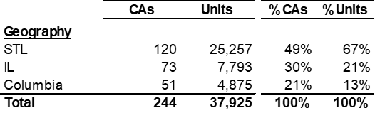

Employee Breakdown
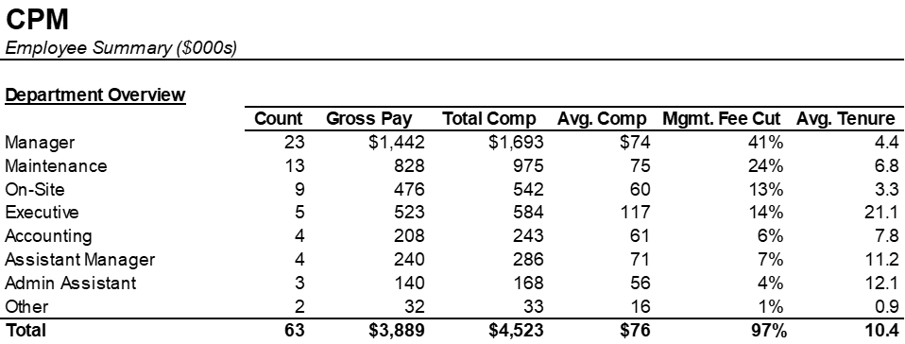

Commentary:
CPM operates with a CAM cut and mgmt. fee cut in-line with our industry expectations. Sellers noted that all but one manager currently has capacity to take additional accounts, and no additional managers are needed for the foreseeable future.

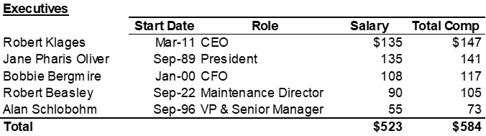

Commentary:
Even though Jane (who owns 48% of the company) has the “President” title, she’s primarily responsible for corporate accounting and otherwise serves in an advisory roll. Bobbie (who owns 5% of the company) oversees the client financials.

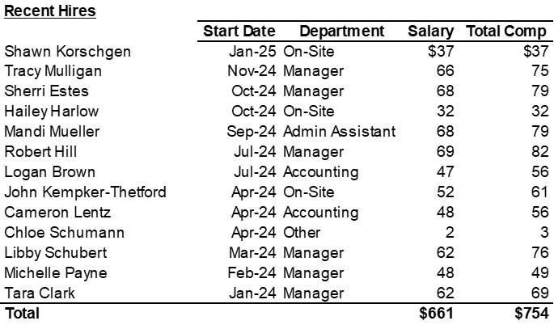

Commentary:
CPM recently hired 13 employees over the past year, mostly consisting of on-site and portfolio managers. Sellers noted that they had been successful in hiring experienced managers off of competitors, and as such do not have a significant training function (beyond Vantaca onboarding).

